**Hosting my Static Website in an AWS S3 Bucket + CloudFront + Route 53**

**Serving end-users with Amazon Route 53 — Final Part**

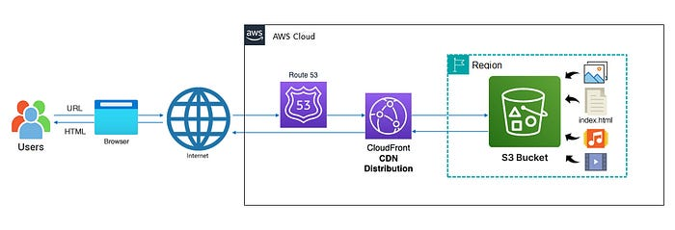

— Architecture Diagram of Hosting my Professional Resume Website in an AWS S3 Bucket + CloudFront + Route 53 (picture by author) — Final

In my introductory “[**Hosting my Static Website in an AWS S3 Bucket — Part 1**](https://medium.com/@rogernem/hosting-my-static-website-in-an-aws-s3-bucket-d5e1d94417f4)” article of a series dedicated to guide you on how to host a static website in an AWS S3 Bucket, I showed the step-by-step to do exactly that.

As an improvement of my initial solution, [part 2 of the series](https://medium.com/@rogernem/hosting-my-static-website-in-an-aws-s3-bucket-cloudfront-part-2-3b71e3375a1f) used Amazon CloudFront to securely deliver our static website content with low latency and high transfer speeds to our end-users.

In this last part of my series, we will route end users to our static website on Amazon S3 using Route 53, a dependable and economical approach to accomplish this.

# Table of Contents

1. [Route 53](https://medium.com/@rogernem/hosting-my-static-website-in-an-aws-s3-bucket-cloudfront-route-53-3ad8d26b22f1#94f1)
2. [Before you Begin](https://medium.com/@rogernem/hosting-my-static-website-in-an-aws-s3-bucket-cloudfront-route-53-3ad8d26b22f1#2f47)  
   [Registering a new domain using Route 53](https://medium.com/@rogernem/hosting-my-static-website-in-an-aws-s3-bucket-cloudfront-route-53-3ad8d26b22f1#2b2f)  
   [Making Amazon Route 53 the DNS service for my existing domain](https://medium.com/@rogernem/hosting-my-static-website-in-an-aws-s3-bucket-cloudfront-route-53-3ad8d26b22f1#b9d1)
3. [Routing traffic to our website on Amazon S3 with Route 53](https://medium.com/@rogernem/hosting-my-static-website-in-an-aws-s3-bucket-cloudfront-route-53-3ad8d26b22f1#0fdd)
4. [Testing our Website URL](https://medium.com/@rogernem/hosting-my-static-website-in-an-aws-s3-bucket-cloudfront-route-53-3ad8d26b22f1#5465)
5. [Requesting our Digital Certificate (Bonus)](https://medium.com/@rogernem/hosting-my-static-website-in-an-aws-s3-bucket-cloudfront-route-53-3ad8d26b22f1#2d11)
6. [Updating the DNS record to point to our CloudFront distribution](https://medium.com/@rogernem/hosting-my-static-website-in-an-aws-s3-bucket-cloudfront-route-53-3ad8d26b22f1#7907)

# Route 53

[Amazon Route 53](https://aws.amazon.com/route53/) is a scalable and highly available Domain Name System (DNS) web service offered by Amazon Web Services (AWS). It is designed to route end users to internet applications by translating domain names into numeric IP addresses that computers use to connect with each other. Route 53 effectively manages the domain names, and it can be used to:

1. **Register Domain Names:** Route 53 allows users to register new domain names or transfer existing ones.
2. **DNS Routing:** It provides DNS routing capabilities, allowing users to route traffic to various AWS services like EC2 instances, S3 buckets, or load balancers, as well as external resources.
3. **Health Checks and Failover:** Route 53 can monitor the health of endpoints and reroute traffic away from unhealthy endpoints to healthy ones automatically.
4. **Traffic Policies:** Users can define routing policies based on various parameters such as geographic location, latency, or weighted round-robin to optimize traffic flow and improve performance.
5. **DNSSEC (Domain Name System Security Extensions):** Route 53 supports DNSSEC, which helps ensure the integrity and authenticity of DNS data.

Overall, Route 53 provides a reliable, scalable, and cost-effective solution for managing domain names and routing internet traffic to AWS resources and beyond.

# Before you begin

You can use Amazon Route 53 with domains you register with Route 53, and with domains you have registered with other DNS providers.

Depending on your DNS provider, you can choose one of the following procedures to register and use a new domain with Route 53:

* For registering a new domain, see **Registering a new domain using Route 53**.
* For an existing domain, see **Making Amazon Route 53 the DNS service for my existing domain**.
* For moving a domain to another registrar, see **update name servers when you want to use another DNS service**.

NOTE: You can navigate directly to the desired section by clicking on the corresponding option above.

Amazon S3 website endpoints do not support HTTPS or access points. If you want to use HTTPS, you can use Amazon CloudFront to serve a static website hosted on Amazon S3. For more information, see [How do I use CloudFront to serve a static website hosted on Amazon S3?](https://aws.amazon.com/premiumsupport/knowledge-center/cloudfront-serve-static-website/) and [Requiring HTTPS for communication between viewers and CloudFront](https://docs.aws.amazon.com/AmazonCloudFront/latest/DeveloperGuide/using-https-viewers-to-cloudfront.html).

## Registering a new domain using Route 53

The example shows how to create Route 53 alias records that route traffic for rogernem.com and subdomain www.rogernem.com to the Amazon S3 bucket that contains our static website.

1. Sign in to the AWS Management Console and open the Route 53 console at <https://console.aws.amazon.com/route53/>
2. In the navigation pane, choose **Domains** and then **Registered domains**.

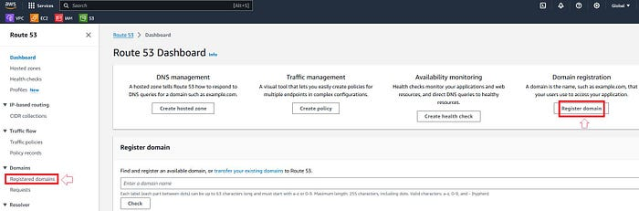

Route 53 Dashboard — Register Domain (picture by author)

**NOTE**: You can also click on “Register domain” under **Domain registration**.

3. On the **Registered domains** page, choose **Register domains**.

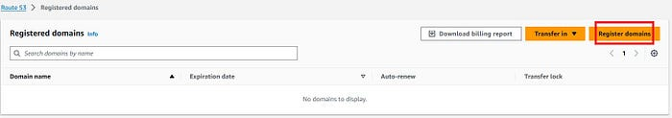

AWS **Registered domains** page (picture by author)

4. In the **Search for domain** section, enter the domain name that you want to register, and choose **Search** to find out whether the domain name is available.

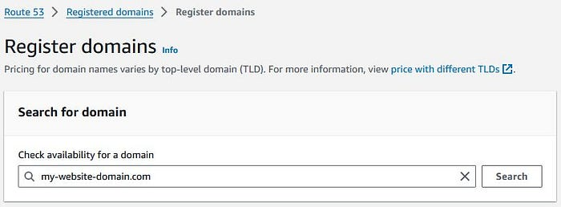

AWS Register domains — Search (picture by author)

If the domain you entered is available, it will be displayed, if not, similar domains will be displayed as suggestions.

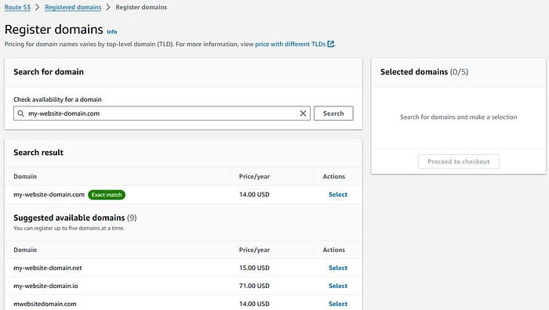

AWS Register domains — Search results (picture by author)

Click on “**Select**” to select your domain.

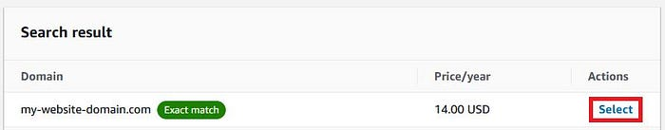

AWS Register domains — Selecting domain to register (picture by author)

You can choose up to five domains to register. The domains you select appear in the **Selected domains** list.

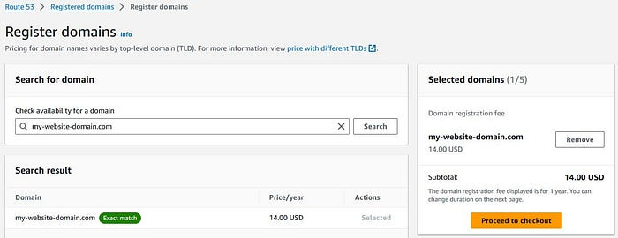

AWS Register domains — Domain selected to be registered (picture by author)

To register more domains, repeat steps above. Once done, choose **Proceed to checkout**.

On the **Pricing** page, choose the number of years that you want to register the domain for and whether you want AWS to automatically renew your domain registration before the expiration date.

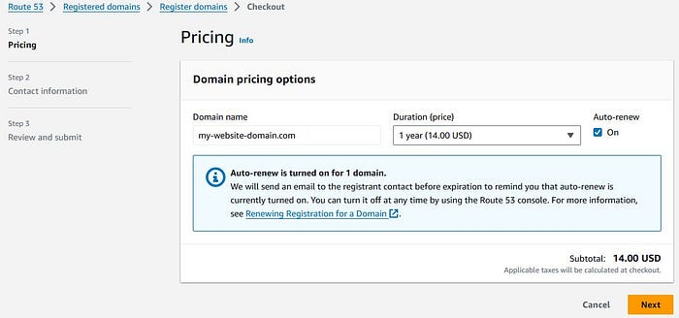

AWS Register domains — Pricing (picture by author)

**NOTE**: Domain name registrations and renewals are not refundable. If you enable automatic domain renewal and you decide that you don’t want the domain name after the registration is renewed, you can’t get a refund for the cost of the renewal.

Choose **Next**.

On the **Contact information** page, enter contact information for the domain registrant, admin, tech, and billing contacts. The values that you enter are applied to all of the domains that you’re registering.

For more information, see [Values that you specify when you register or transfer a domain](https://docs.aws.amazon.com/Route53/latest/DeveloperGuide/domain-register-values-specify.html).

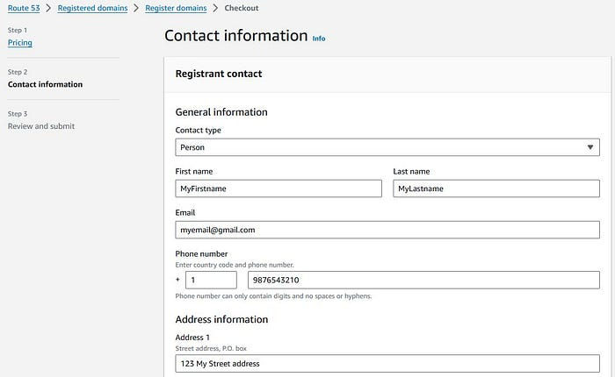

AWS Register domains — Contact Information (picture by author)

Choose **Next**.

On the **Review** page, review the information that you entered, and optionally correct it, read the terms of service, and select the check box to confirm that you’ve read the terms of service.

Choose **Submit**.

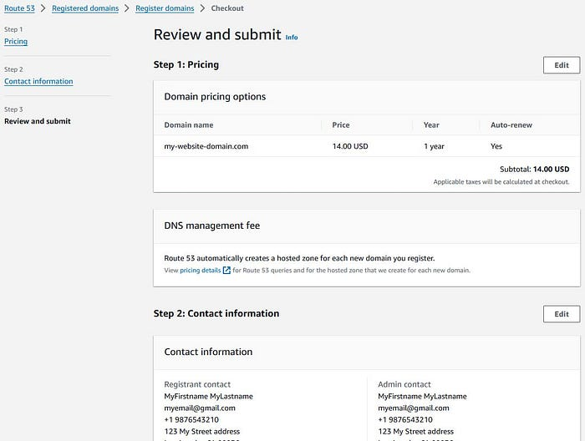

AWS Register domains — Review and Submit (picture by author)

Upon submitting your order, a notification confirming the submission and indicating that the payment will be debited from your designated payment method will appear. Simply click “Close” and then proceed by clicking the “Go to Domains” button.

When the domain registration is complete, your next step depends on whether you want to use Route 53 or another DNS service as the DNS service for the domain:

* **Route 53** — In the hosted zone that Route 53 created when you registered the domain, create records to tell Route 53 how you want to route traffic for the domain and subdomains.
* **Another DNS service** — Configure your new domain to route DNS queries to the other DNS service. Perform the procedure [Updating name servers to use another registrar](https://docs.aws.amazon.com/Route53/latest/DeveloperGuide/domain-register-other-dns-service.html).

## Making Amazon Route 53 the DNS service for my existing domain

If you’re transferring one or more domain registrations to Route 53 and your current domain registrar doesn’t offer paid DNS service, it’s crucial to migrate your DNS service before initiating the domain transfer.

Failure to do so may result in the registrar ceasing DNS service upon domain transfer, rendering associated websites and web applications inaccessible on the internet.

Assuming the domain is currently getting traffic — see [Making Route 53 the DNS service for a domain that’s in use](https://docs.aws.amazon.com/Route53/latest/DeveloperGuide/migrate-dns-domain-in-use.html).

Your domain should remain accessible throughout the entire migration process. However, in the rare event of any issues, the option provided above allows for a swift rollback of the migration.

# Routing traffic to our website on Amazon S3 with Route 53

To direct domain traffic to our S3 bucket, we’ll utilize Amazon Route 53 to establish an [alias record](https://docs.aws.amazon.com/Route53/latest/DeveloperGuide/resource-record-sets-choosing-alias-non-alias.html) that points to it.

An alias record, an extension within Route 53’s DNS capabilities, operates akin to a CNAME record. However, unlike a CNAME record, an alias record can be created for both the root domain (e.g., example.com) and its subdomains (e.g., [www.example.com](http://www.example.com)). CNAME records are limited to subdomains exclusively.

You can efficiently direct traffic for a domain and its subdomains, like example.com and [www.example.com](http://www.example.com), to a singular bucket. This involves creating a bucket for the main domain and each subdomain, then configuring all buckets except one to redirect traffic to the remaining bucket.

1. Sign in to the AWS Management Console and open the Route 53 console at <https://console.aws.amazon.com/route53/>
2. In the navigation pane, choose **Hosted zones**.

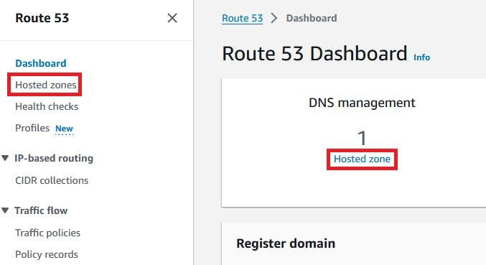

Route 53 Dashboard — Hosted zone (picture by author)

3. Choose the name of the hosted zone that has the domain name that you want to use to route traffic to your S3 bucket (e.g. rogernem.com).

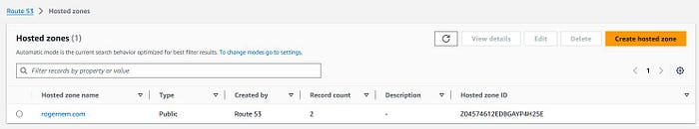

AWS Hosted zones — domain (picture by author)

4. Choose **Create record**.

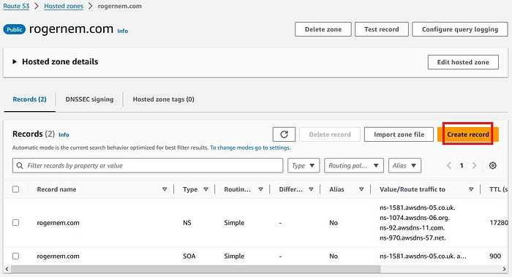

AWS Hosted zones — Records (picture by author)

On the Create record page, you will create an alias record for your Apex/root domain so that it will redirect to your S3 Bucket website. You will accomplish this by entering the following information:

Alias: toggle the switch to “on”

* **Route traffic to:** Alias to S3 endpoint
* **Region:** Choose the Region for your S3 endpoint
* **Enter S3 endpoint:** Select your S3 Bucket from the list
* **Routing Policy:** Simple Routing

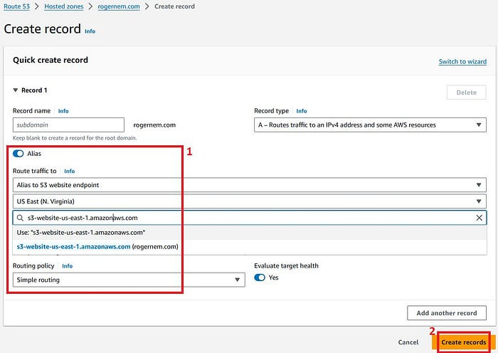

AWS Hosted zones > rogernem.com — Create record (picture by author)

Following this, you’ll receive confirmation verifying the successful creation of the DNS record for your domain.

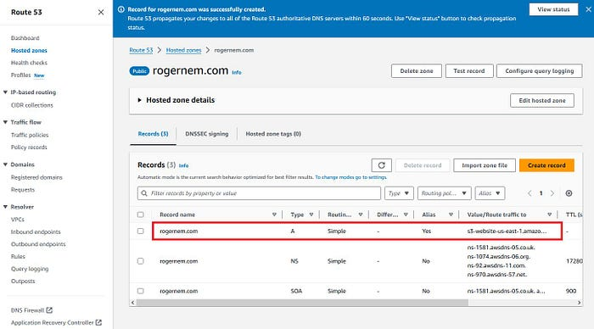

AWS Hosted zones — Record for rogernem.com was successfully created (picture by author)

Changes generally propagate to all Route 53 servers within 60 seconds. When propagation is done, you’ll be able to route traffic to your S3 bucket by using the name of the alias record that you created in this procedure.

# Testing our Website URL

Navigate to the FQDN of your domain in your web browser and your website should be available once the DNS records have had enough time to complete the propagation process.

Congratulations! You have completed the hosting of a static website on an Amazon S3 bucket!

Noticeably, the browser displays a warning indicating that the website is unsecured and not trusted.

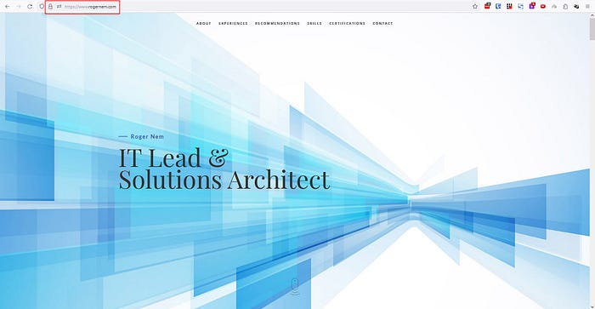

My Professional Resume Website — [www.rogernem.com](http://www.rogernem.com) (picture by author) — Unsecure

This concern can be addressed by obtaining an SSL certificate for our site from a Certificate Authority. Luckily, AWS provides a solution called [Amazon Certificate Manager](https://aws.amazon.com/certificate-manager/) (ACM), enabling us to request a certificate for our site free of charge. Let’s proceed with this step!

# Requesting our Digital Certificate (Bonus)

[Amazon Certificate Manager (ACM)](https://aws.amazon.com/certificate-manager/) is a service offered by Amazon Web Services (AWS), simplifying the management and deployment of Secure Sockets Layer/Transport Layer Security (SSL/TLS) certificates. It enables users to provision, oversee, and deploy SSL/TLS certificates seamlessly, integrating with various AWS services like Elastic Load Balancing, Amazon CloudFront distributions, and Amazon API Gateway APIs. ACM automates the renewal and replacement of certificates, ensuring continuous security. SSL/TLS certificates facilitate web browsers in identifying and establishing encrypted network connections to websites, enhancing security via the SSL/TLS protocol.

To initiate a certificate request from ACM, start by searching for “certificate manager” in the top search bar, and then select it from the list of services that appears. **IMPORTANT: Ensure that you are in the correct region when requesting your certificate**.

1. On the AWS Certificate Manager page, simply click on the “Request a certificate” button to proceed.

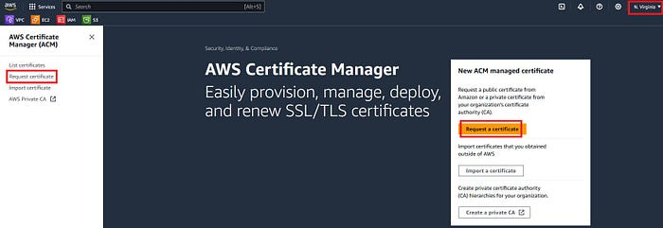

AWS Certificate Manager — Request certificate (picture by author)

2. Select the first radio button labeled “**Request a public certificate**” and then proceed by clicking “**Next**.”

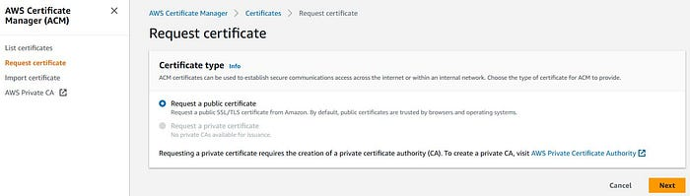

AWS Certificate Manager — Request a public certificate (picture by author)

3. In the “Domain names” section, input the Fully Qualified Domain Name (FQDN) for your domain(s). Then, navigate to the “Validation method” section below and choose an option for validating your domain. **DNS validation** is the recommended choice and can be conveniently completed through the AWS console.

4. Scroll down to the “Key algorithm” section and opt for **RSA 2048** as the encryption algorithm. Once selected, proceed by clicking the “Request” button located below.

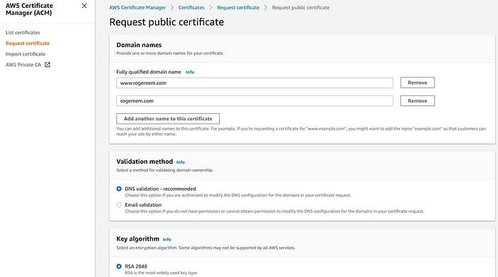

AWS Certificate Manager — Request a public certificate — Options (picture by author)

Following your request, a banner will appear at the top of the Certificates List page, confirming the successful submission of your certificate request.

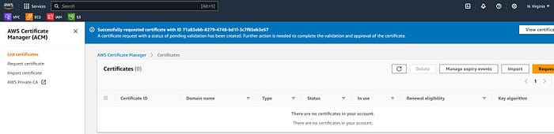

AWS Certificate Manager — Success (picture by author)

You should observe your certificate issuance listed below in a “Pending validation” state. If it does not appear immediately, simply click the refresh button, and it should become visible shortly. Once located, click on the blue text displayed under the “Certificate ID” column to proceed.

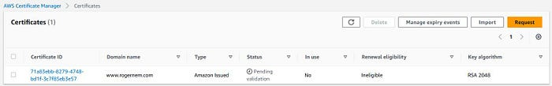

AWS Certificate Manager — Certificates (picture by author)

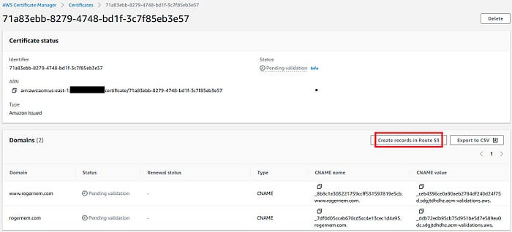

AWS Certificate Manager — Certificates — Create records in Route 53 (picture by author)

On the next page, you will tick the checkbox in front of your domain name and then click the “**Create Record**” button to create the DNS record in Route 53. This will validate your domain ownership so that Route 53 will issue the certificate for your website.

Once you have completed this process, you will notice that your domain validation status is reflected as “success” and the certificate status is “issued”. This completes the certificate process.

NOTE: We need to create a CloudFront distribution for our website so that we can utilize the certificate because we cannot use the certificate with the S3 resource.

Refer to part 2 of my series by clicking below.

## [Hosting my Static Website in an AWS S3 Bucket + CloudFront— Part 2](https://medium.com/@rogernem/hosting-my-static-website-in-an-aws-s3-bucket-cloudfront-part-2-3b71e3375a1f?source=post_page-----3ad8d26b22f1--------------------------------" \t "_blank)

### [Serving end-users with Amazon CloudFront](https://medium.com/@rogernem/hosting-my-static-website-in-an-aws-s3-bucket-cloudfront-part-2-3b71e3375a1f?source=post_page-----3ad8d26b22f1--------------------------------" \t "_blank)

[www.rogernem.com](https://medium.com/@rogernem/hosting-my-static-website-in-an-aws-s3-bucket-cloudfront-part-2-3b71e3375a1f?source=post_page-----3ad8d26b22f1--------------------------------" \t "_blank)

# Updating the DNS record to point to our CloudFront distribution

For this final step, let’s update the DNS record to direct to our CloudFront distribution. Begin by searching for “Route 53” in the top search bar and select it from the list of services that appears.

1. From the Route 53 Dashboard, choose **Hosted zones**.



Route 53 Dashboard — Hosted zone (picture by author)

2. Choose the name of the hosted zone that has the domain name that you want to use (e.g. rogernem.com).



AWS Hosted zones — domain (picture by author)

3. Please select the checkbox next to your A record for your domain. Once selected, an Edit pane will open on the right. Modify the “Route traffic to” field so that the chosen option is now “**Alias to CloudFront distribution**,” then proceed by clicking “Save.”

Congratulations! You’ve successfully completed all the necessary steps for deploying a secure static website on AWS, utilizing Route 53 and CloudFront. Well done! 🎉

**If you enjoyed this article and found it helpful, please don’t forget to leave a heart** ❤**, comment** 💬**, clap** 👏🏻**, and share** ➦ **it to show your support.**

**Also, don’t forget to** [**connect**](https://www.linkedin.com/in/rogertn/)**,** [**follow me**](https://medium.com/@rogernem) **for more articles and support me by** [buying me a coffee](https://buymeacoffee.com/rogernem)**.** :-) **Thank you!**

References:  
- <https://aws.amazon.com/route53/>  
- <https://docs.aws.amazon.com/Route53/latest/DeveloperGuide/domain-register.html>  
- <https://docs.aws.amazon.com/Route53/latest/DeveloperGuide/domain-register-other-dns-service.html>  
- <https://docs.aws.amazon.com/Route53/latest/DeveloperGuide/MigratingDNS.html>  
- <https://docs.aws.amazon.com/Route53/latest/DeveloperGuide/migrate-dns-domain-in-use.html>  
- <https://aws.amazon.com/certificate-manager/>

[AWS](https://medium.com/tag/aws?source=post_page-----3ad8d26b22f1---------------aws-----------------)

[Aws In Plain English](https://medium.com/tag/aws-in-plain-english?source=post_page-----3ad8d26b22f1---------------aws_in_plain_english-----------------)

[Cloudfront](https://medium.com/tag/cloudfront?source=post_page-----3ad8d26b22f1---------------cloudfront-----------------)

[Ssl Certificate](https://medium.com/tag/ssl-certificate?source=post_page-----3ad8d26b22f1---------------ssl_certificate-----------------)

[Route 53](https://medium.com/tag/route-53?source=post_page-----3ad8d26b22f1---------------route_53-----------------)